TOPIC/TITLE

For loop

Keywords/Questions  for loop | Notes :
Keywords/Questions  for loop | Works the same way as whole loop but in spite of checking a condition we specify the number of loop.
Keywords/Questions  for loop | For (i=0 ; i<2 ; i++) {/:do something}
Keywords/Questions  for loop | 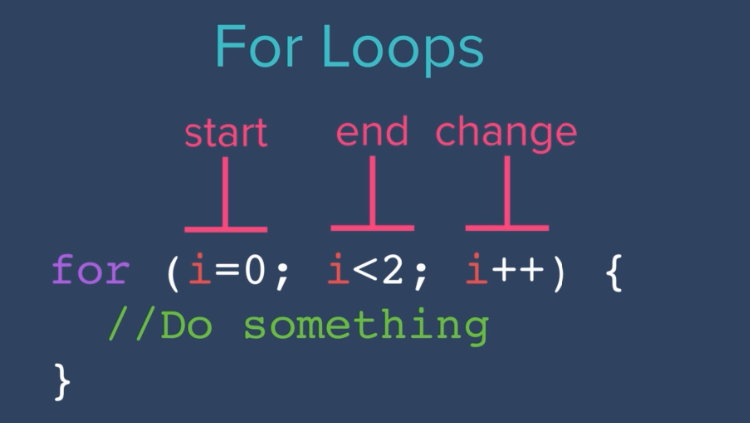
Keywords/Questions  for loop | When do I sue while or for
Keywords/Questions  for loop | While is used until a statement is true ( that can be while the player is alive)  you want to repeaditly run an instruction while the program is in certain state.
Keywords/Questions  for loop | For loop : you essentially try to iterate. You try to run a piece of code many many times and you're going the for loop to define how may times.

